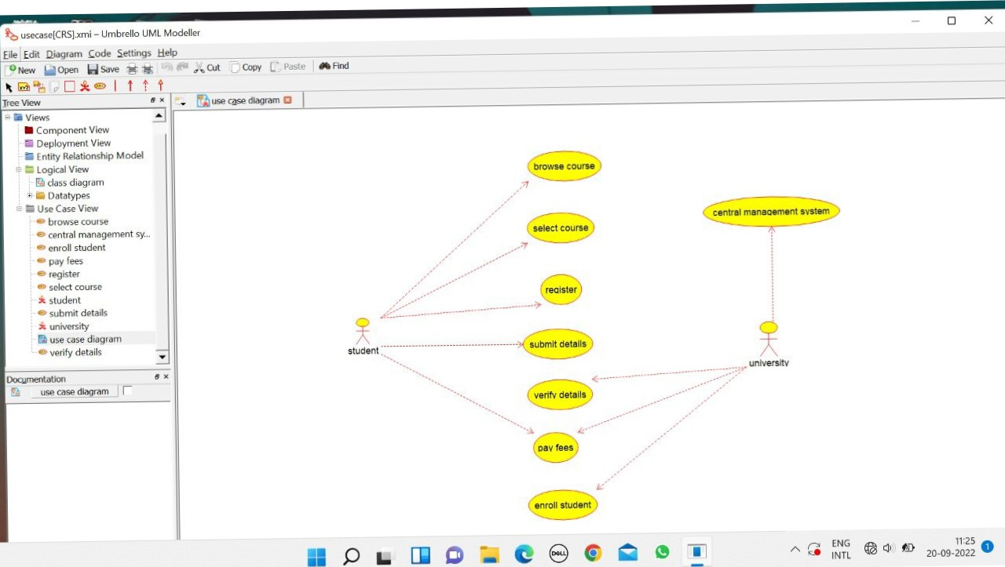



Central Management System:

/**

* Class CENTRAL_MANAGEMENT_SYSTEM

*/

public class CENTRAL_MANAGEMENT_SYSTEM {

//

// Fields

//

private void store_details;

private void verify_details;

//

// Constructors

//

public CENTRAL_MANAGEMENT_SYSTEM () { };

//

// Methods

//

//

// Accessor methods

//

/**

* Set the value of store_details

* @param newVar the new value of store_details

*/

private void setStore_details (void newVar) {

store_details = newVar;

}

/**

* Get the value of store_details

* @return the value of store_details

*/

private void getStore_details () {

return store_details;

}

/**

* Set the value of verify_details

* @param newVar the new value of verify_details

*/

private void setVerify_details (void newVar) {

verify_details = newVar;

}

/**

* Get the value of verify_details

* @return the value of verify_details

*/

private void getVerify_details () {

return verify_details;

}

//

// Other methods

//

/**

*/

public void verify()

{

}

/**

*/

public void enroll()

{

}

}

STUDENT

/**

* Class STUDENT

*/

public class STUDENT {

//

// Fields

//

private void name;

private void address;

private void marks;

//

// Constructors

//

public STUDENT () { };

//

// Methods

//

//

// Accessor methods

//

/**

* Set the value of name

* @param newVar the new value of name

*/

private void setName (void newVar) {

name = newVar;

}

/**

* Get the value of name

* @return the value of name

*/

private void getName () {

return name;

}

/**

* Set the value of address

* @param newVar the new value of address

*/

private void setAddress (void newVar) {

address = newVar;

}

/**

* Get the value of address

* @return the value of address

*/

private void getAddress () {

return address;

}

/**

* Set the value of marks

* @param newVar the new value of marks

*/

private void setMarks (void newVar) {

marks = newVar;

}

/**

* Get the value of marks

* @return the value of marks

*/

private void getMarks () {

return marks;

}

//

// Other methods

//

/**

*/

public void browse()

{

}

/**

*/

public void select()

{

}

/**

*/

public void register()

{

}

}

UNIVERSITY

/**

* Class UNIVERSITY

*/

public class UNIVERSITY {

//

// Fields

//

private void store_details;

private void verify_details;

//

// Constructors

//

public UNIVERSITY () { };

//

// Methods

//

//

// Accessor methods

//

/**

* Set the value of store_details

* @param newVar the new value of store_details

*/

private void setStore_details (void newVar) {

store_details = newVar;

}

/**

* Get the value of store_details

* @return the value of store_details

*/

private void getStore_details () {

return store_details;

}

/**

* Set the value of verify_details

* @param newVar the new value of verify_details

*/

private void setVerify_details (void newVar) {

verify_details = newVar;

}

/**

* Get the value of verify_details

* @return the value of verify_details

*/

private void getVerify_details () {

return verify_details;

}

//

// Other methods

//

/**

*/

public void verify()

{

}

/**

*/

public void enroll()

{

}

}

